Formatting Template for CS Academic Report

(revised September 2021)

Module Name: <module code>

Date: <date>

Submitted as part of the degree of [e.g. MEng Computer Science] to the

Board of Examiners in the Department of Computer Sciences, Durham University

**Abstract** — These instructions give you guidelines for preparing your module report. DO NOT change any settings, such as margins and font sizes. Just use this as a template and modify the contents into your final report. An abstract should be 100 to 200 words, and should clearly state the nature and significance of the report. Abstracts must not include mathematical expressions or bibliographic references. Please note that abstracts are formatted as left justified in our editing template (as shown here).

**Index Terms**—Keywords should closely reflect the topic and should optimally characterize the report. Use about four keywords or phrases in alphabetical order, separated by commas (there should not be a period at the end of the index terms)

xxxx-xxxx/0x/$xx.00 © 200x IEEE Published by the IEEE Computer Society

—————————— ◆ ——————————

# 1 Introduction

T

HIS section briefly introduces the general background, the issue you are addressing, and any objectives being examined. Do not change the font sizes or line spacing in order to put in more text.

NOTE: that the size of the report, including the references, is dictated by the coursework - please check and ensure that you do not go over the assigned page limit.

NOTE: references to Web based pages should be less than 10\% of the total reference count.

# 2 Related Work

This section presents a survey of existing work on the problems that this report addresses. The rest of this section shows the formats of subsections as well as some general formatting information for tables, figures, references and equations.

## 2.1 Main Text

The font used for the main text should be Palatino and the font size should be 9.5. The first line of all paragraphs should be indented by 0.5cm, except for the first paragraph of each section, subsection, subsubsection etc. (the paragraph immediately after the header) where no indentation is needed.

## 2.2 Figures and Tables

In general, figures and tables should not appear before they are cited. Place figure captions below the figures; place table titles above the tables. If your figure has two parts, for example, include the labels “(a)” and “(b)” as part of the artwork. Please verify that figures and tables you mention in the text actually exist. Make sure that all tables and figures are numbered as shown in Table 1 and Figure 1 below.

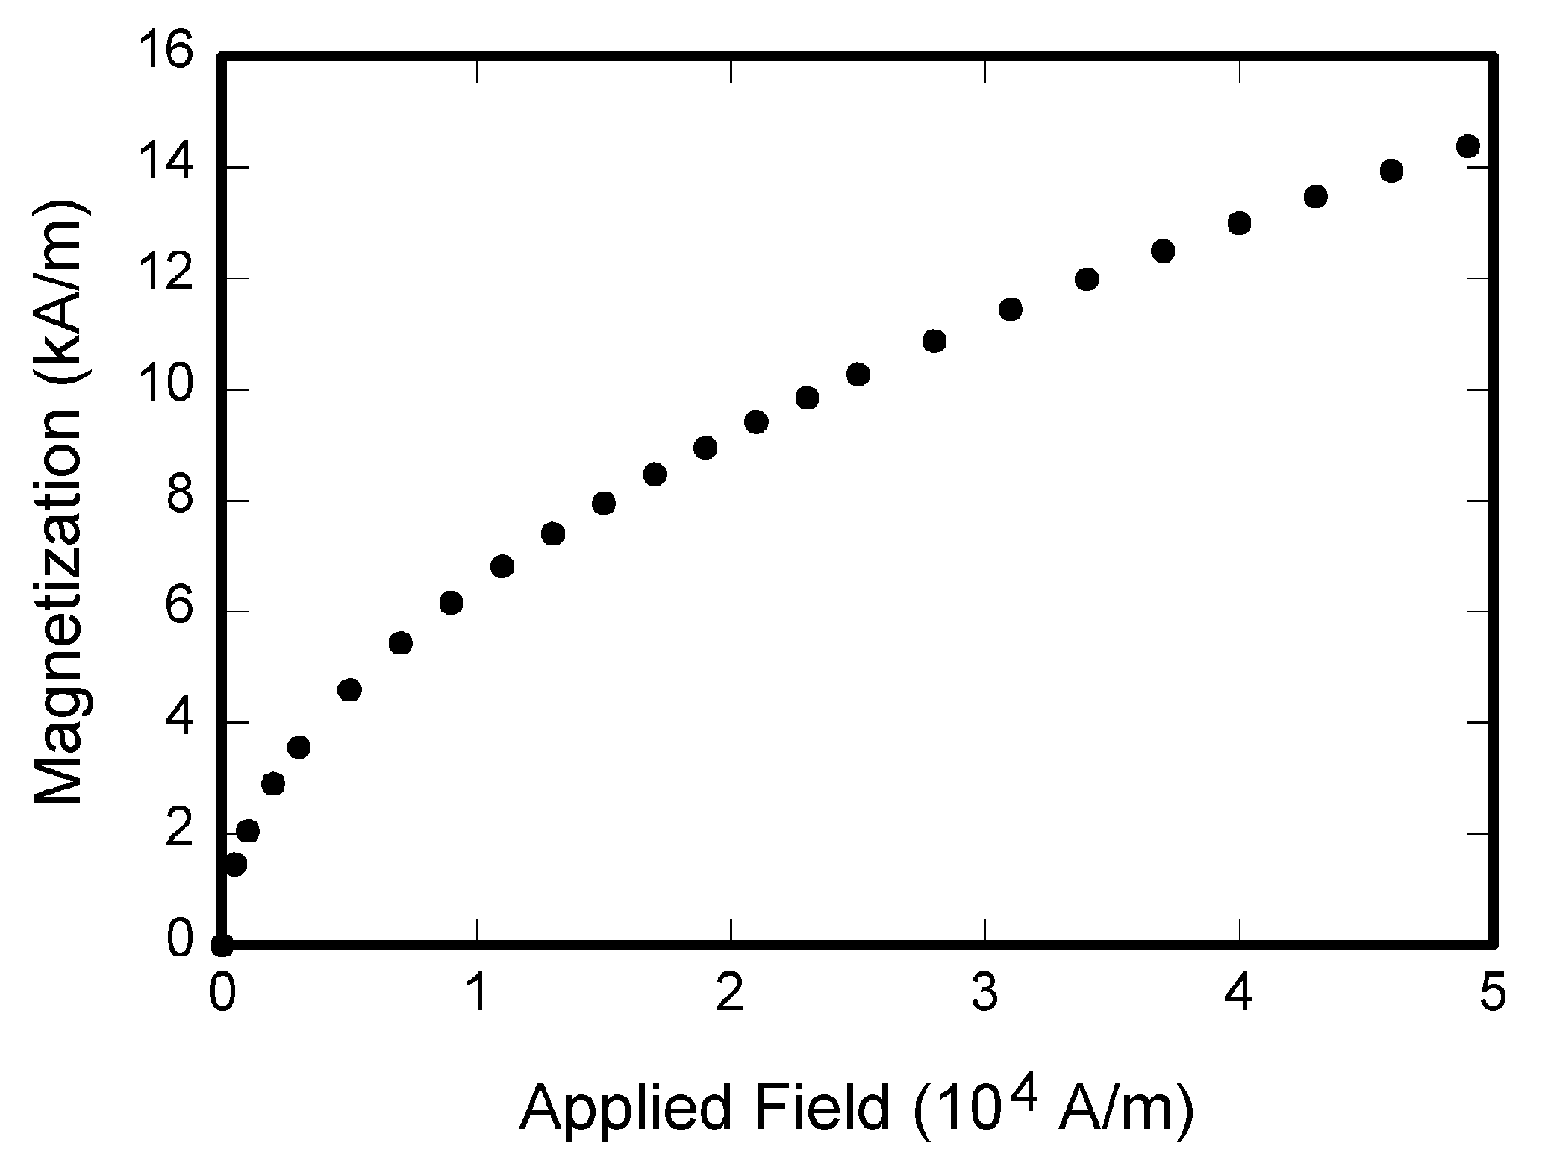

**Fig 1.** Magnetization as a function of applied field. There is a period after the figure number, followed by two spaces. It is good practice to explain the significance of the figure in the caption

## 2.3 References

The list of cited references should appear at the end of the report, listed by order of appearance in the paper. The required style is to note citations in individual brackets, followed by a comma, e.g. “[1], [5]” (as opposed to the more common “[1, 5]” form.) Citation ranges should be formatted as follows: [1], [2], [3], [4] (as opposed to [1]-[4]). When citing a section in a book, please give the relevant page numbers [2]. In sentences, refer simply to the reference number, as in [3]. Do not use “Ref. [3]” or “reference [3]” At the beginning of a sentence use the author names instead of “Reference [3],” e.g., “Smith and Smith [3] show ... .”.

# 3 Methodology

This section presents the solutions to the problems in detail. The design and implementation details should all be placed in this section. You may create a number of sub-sections, each focusing on one issue.

TABLE 1  
Units for Magnetic Properties

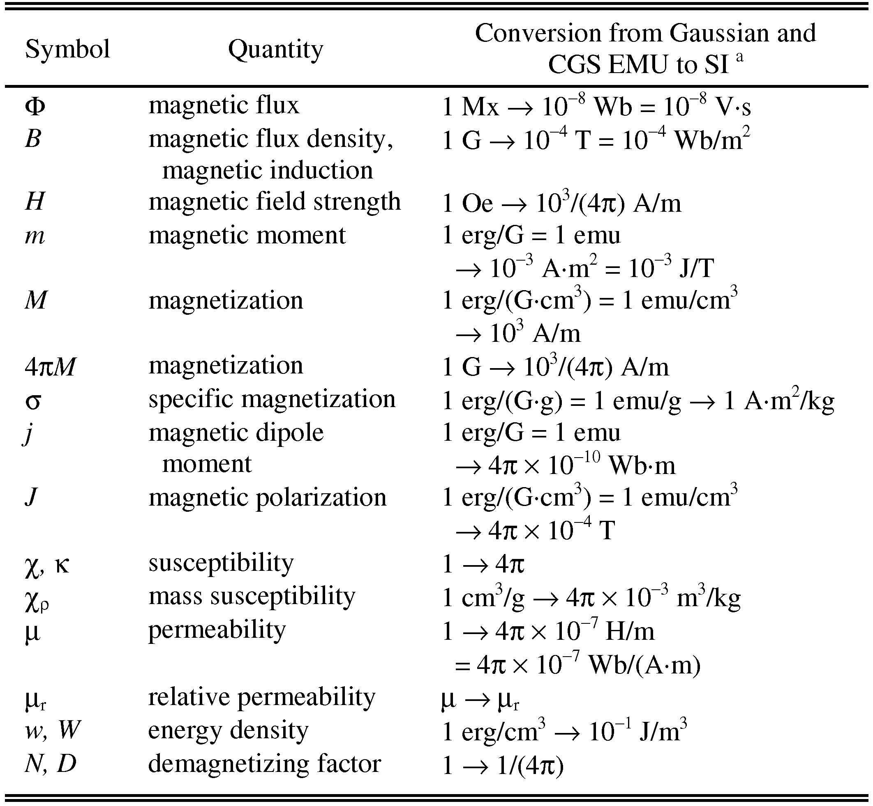

Statements that serve as captions for the entire table do not need footnote letters. E.g. Mx = maxwell, G = gauss, Oe = oersted; Wb = weber, V = volt, s = second, T = tesla, m = meter, A = ampere, J = joule, kg = kilogram, H = henry.

# 4 Main Body

This section will detail the main body to the report and cover all of the content as required by the assignment.

Add more 'sections', 'subsections' etc ... as required.

# 5 Conclusions

This section summarises the main points of this report. Do not replicate the abstract as the conclusion. A conclusion might elaborate on the most interesting finding or importance of the work or suggest applications and extensions.

The page lengths given here are indicative and will between coursework submissions but should not exceed the upper limit as detailed in the assignment. An example summary is shown in Table 2.

Table 2:   
Summary of Page Lengths for Sections

|  |  |
| --- | --- |
| Section | Number of Pages |
| I. Introduction | 2–3 |
| II. Related Work | 2–3 |
| III. Solution | 4–7 |
| IV. Results | 2–3 |
| V. Evaluation | 1-2 |
| VI. Conclusions | 1 |

**References**

1. J.S. Bridle, *Probabilistic Interpretation of Feedforward Classification Network Outputs, with Relationships to Statistical Pattern Recognition*, Neurocomputing—Algorithms, Architectures and Applications, F. Fogelman-Soulie and J. Herault, eds., NATO ASI Series F68, Berlin: Springer-Verlag, pp. 227-236, 1989. (Book style with paper title and editor)
2. W.-K. Chen, *Linear Networks and Systems,* Belmont, Calif.: Wadsworth, pp. 123-135, 1993. (Book style)
3. H. Poor, *A Hypertext History of Multiuser Dimensions*, *MUD History,* http://www.ccs.neu.edu/home/pb/mud-history.html. 1986. (URL link *include year)
4. K. Elissa, *An Overview of Decision Theory*,unpublished. (Unpublished manuscript)